1. **Member – Website user guide**
   1. **Login**

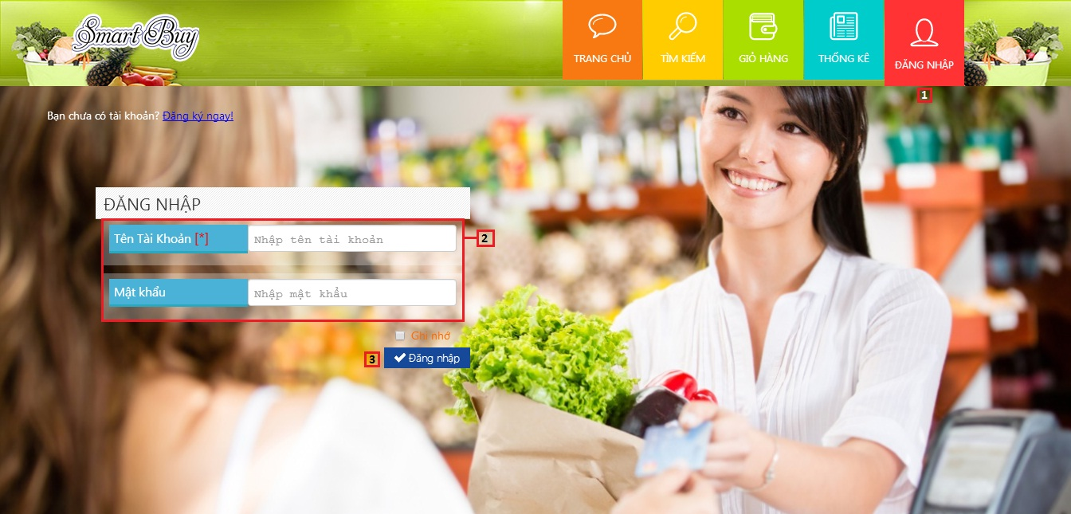

|  |  |
| --- | --- |
| **Step** | **Description** |
| 1 | Click icon “ĐĂNG NHẬP” on menu bar to go to login page |
| 2 | Fill Username and Password |
| 3 | Click button “Đăng nhập” |

* 1. **Define route**

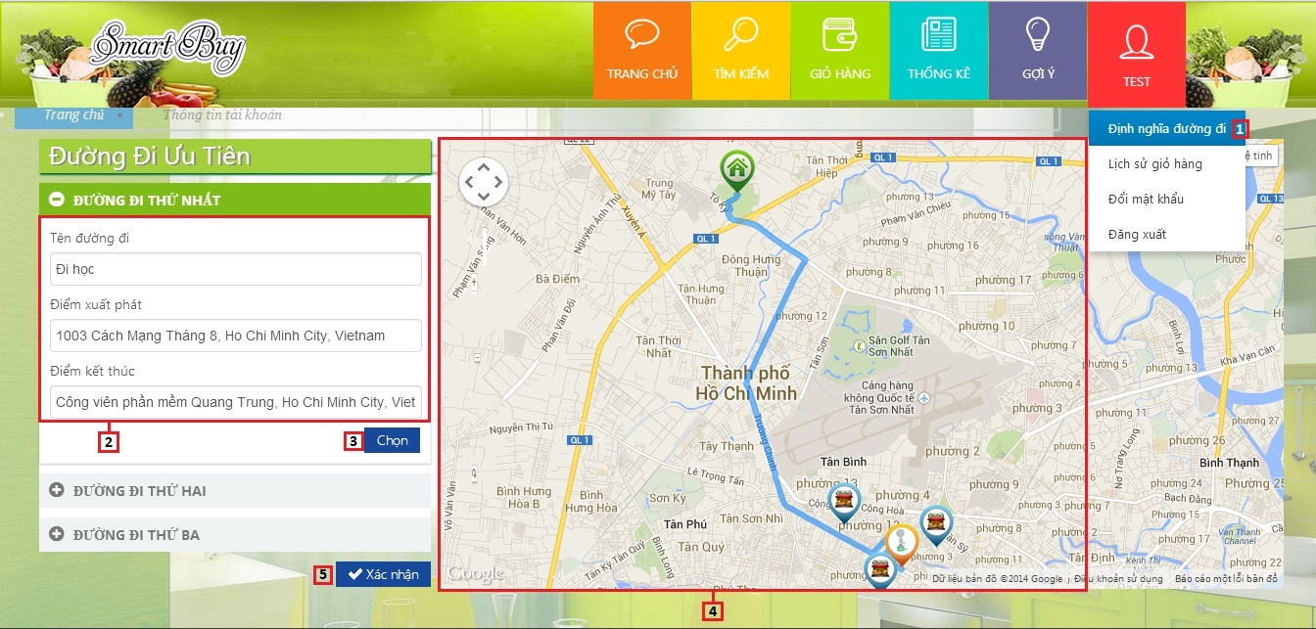

|  |  |
| --- | --- |
| **Step** | **Description** |
| 1 | Click “Đinh nghĩa đường đi” link on menu bar to go to define route page |
| 2 | Fill Route name, start place, finish place |
| 3 | Click button “Chọn” |
| 4 | View route on maps |
| 5 | Click button “Xác nhận” to save route |

* 1. **Search product**

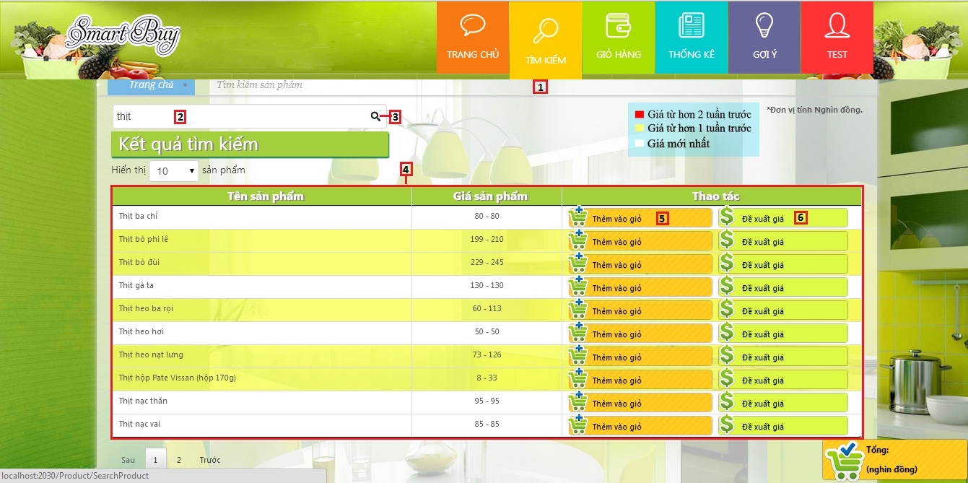

|  |  |
| --- | --- |
| **Step** | **Description** |
| 1 | Click icon “TÌM KIẾM” on menu bar to go to search page |
| 2 | Fill search key |
| 3 | Click icon “Search” to search product |
| 4 | View search product result list (product name, price) |
| 5 | Click button “Thêm vào giỏ” to add product to cart |
| 6 | Click button “Đề xuất giá“ to propose price |

* 1. **Propose product price**

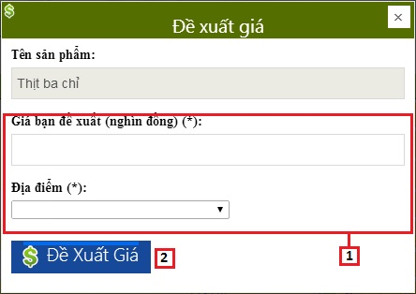

|  |  |
| --- | --- |
| **Step** | **Description** |
| 1 | Fill propose price and market name |
| 2 | Click button “Đề xuất giá” |

* 1. **View suggest route**

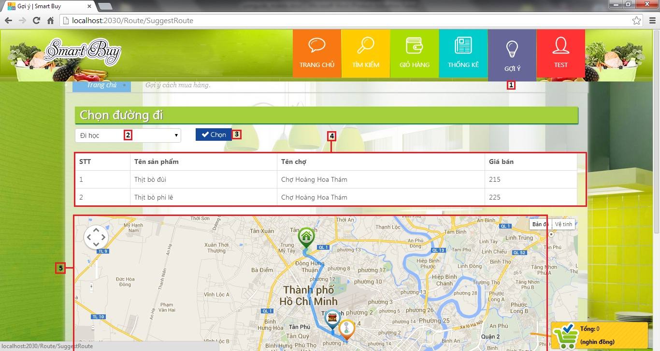

|  |  |
| --- | --- |
| **Step** | **Description** |
| 1 | Click icon “GỢI Ý” on menu bar to go to suggest route page |
| 2 | Select route |
| 3 | Click button “Chọn” |
| 4 | View suggest route list (product name, market, price) |
| 5 | View route on maps |

* 1. **View cart**

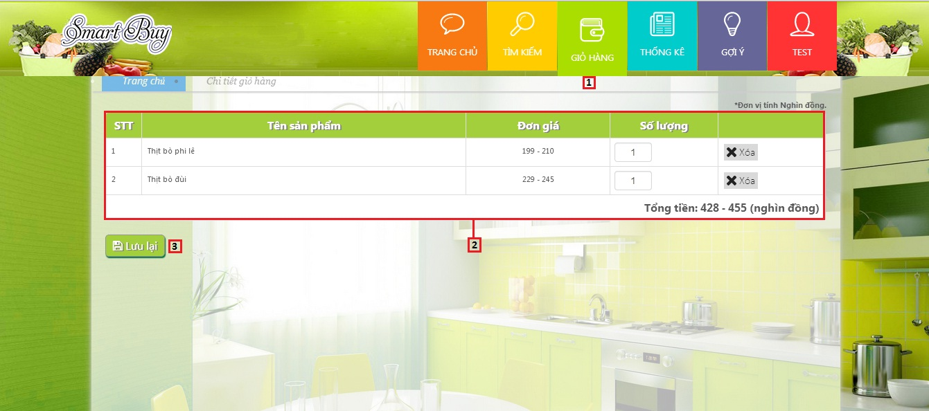

|  |  |
| --- | --- |
| **Step** | **Description** |
| 1 | Click icon “GIỎ HÀNG” to go to view cart page |
| 2 | View cart info (product name, price, quantity) |
| 3 | Click button “Lưu lại” to save cart |

* 1. **View history**

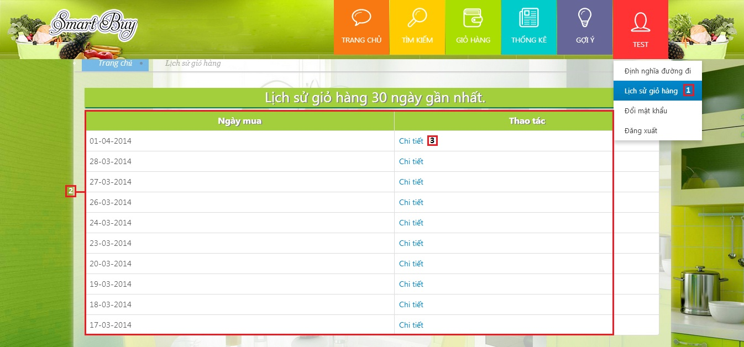

|  |  |
| --- | --- |
| **Step** | **Description** |
| 1 | Click “Lịch sử giỏ hàng” link on menu bar to go to view history page |
| 2 | View history list (date saved) |
| 3 | Click “Chi tiết” link to go to history detail page |

* 1. **View history detail**

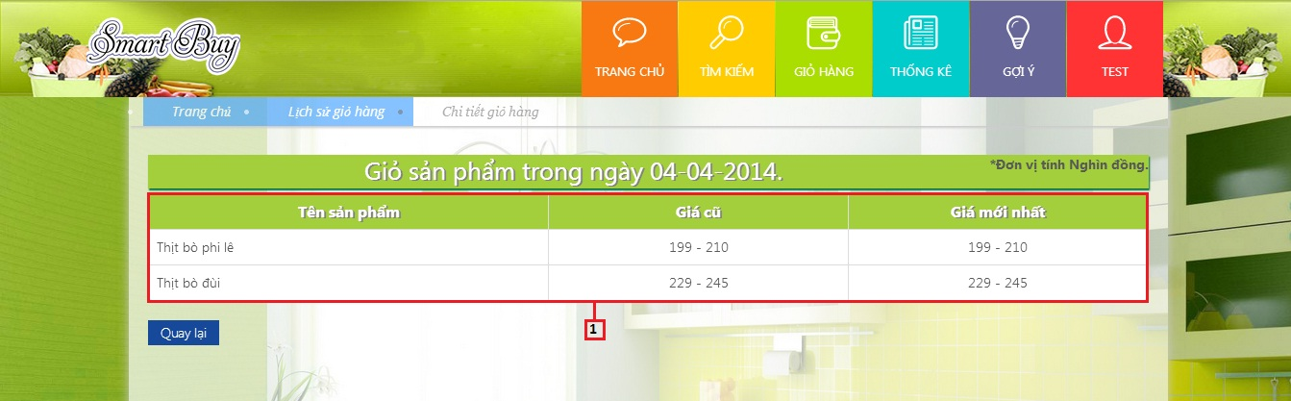

|  |  |
| --- | --- |
| **Step** | **Description** |
| 1 | View history detail list (product name, old price, new price) |

1. **Member – Mobile user guide**
   1. **Login**

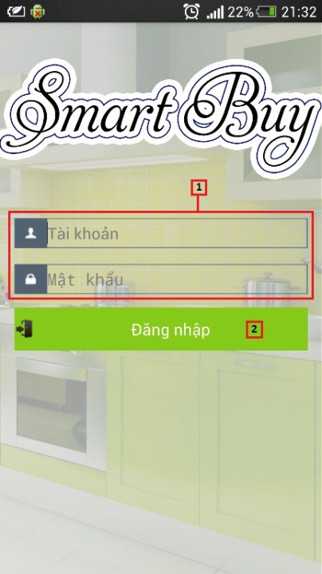

|  |  |
| --- | --- |
| **Step** | **Description** |
| 1 | Fill Username and Password |
| 2 | Click button “Đăng nhập” |

* 1. **View favourite product**

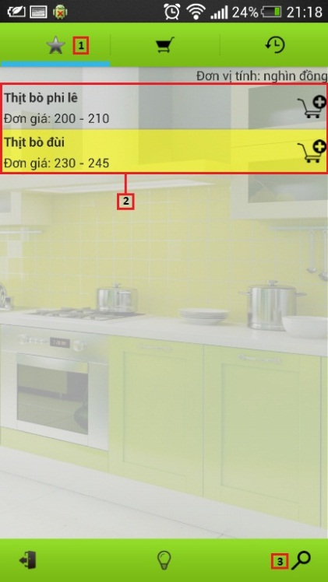

|  |  |
| --- | --- |
| **Step** | **Description** |
| 1 | Click icon  to view favourite product |
| 2 | View favourite product list (product name, price) |
| 3 | Click icon  to search product |

* 1. **Search product**

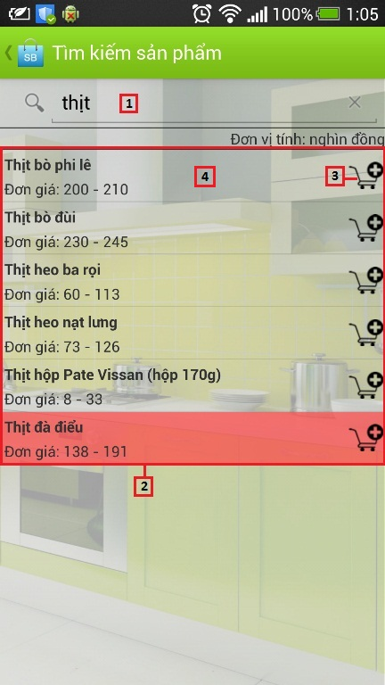

|  |  |
| --- | --- |
| **Step** | **Description** |
| 1 | Fill search key |
| 2 | View search product result list (product name, price) |
| 3 | Click icon  to add product to cart |
| 4 | Click on row to propose price |

* 1. **Propose product price**

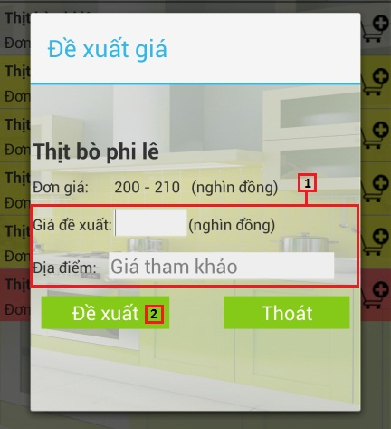

|  |  |
| --- | --- |
| **Step** | **Description** |
| 1 | Fill propose price and market name |
| 2 | Click button “Đề xuất” |

* 1. **View cart**

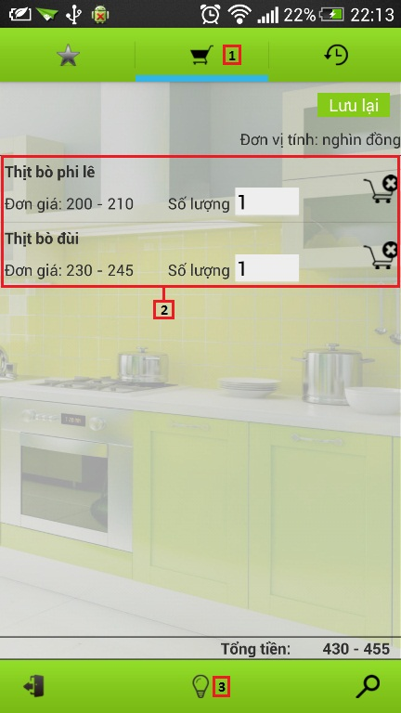

|  |  |
| --- | --- |
| **Step** | **Description** |
| 1 | Click icon  to view cart |
| 2 | View cart info (product name, price, quantity) |
| 3 | Click icon  to view suggest route |

* 1. **View suggest route**

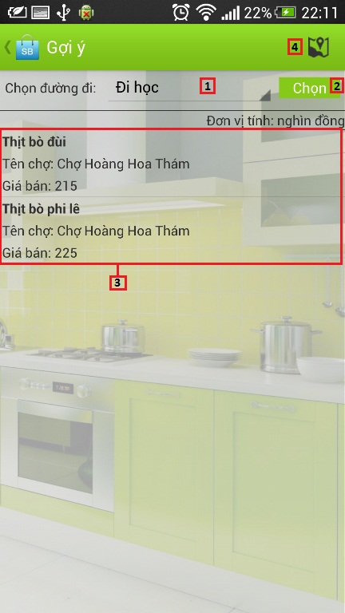

|  |  |
| --- | --- |
| **Step** | **Description** |
| 1 | Select route |
| 2 | Click button “Chọn” |
| 3 | View suggest route list (product name, market, price) |
| 4 | Click icon  to view maps |

* 1. **View maps**

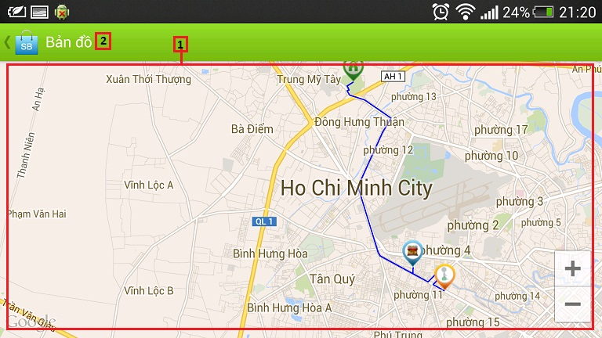

|  |  |
| --- | --- |
| **Step** | **Description** |
| 1 | View route on maps |
| 2 | Click icon  to back suggest route screen |

* 1. **View history**

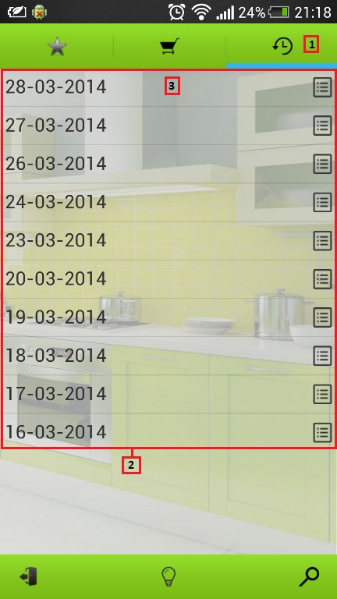

|  |  |
| --- | --- |
| **Step** | **Description** |
| 1 | Click icon  to view history |
| 2 | View history list (date saved) |
| 3 | Click on row to view history detail |

* 1. **View history detail**

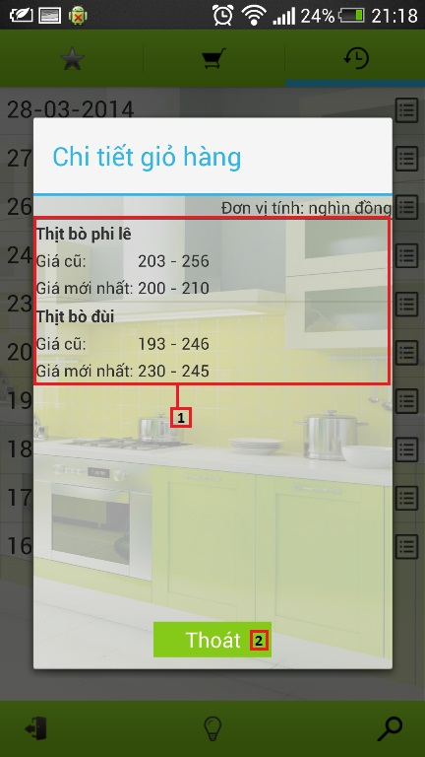

|  |  |
| --- | --- |
| **Step** | **Description** |
| 1 | View history detail list (product name, old price, new price) |
| 2 | Click button “Thoát” to cancel |